**ASSIGNMENT 1**

**TO CASE OF 50 STARTUPS**

|  |  |
| --- | --- |
| Student Name | HARITHA M |
| Student Roll Number | 921319104054 |

1. **R&D SPENDING**

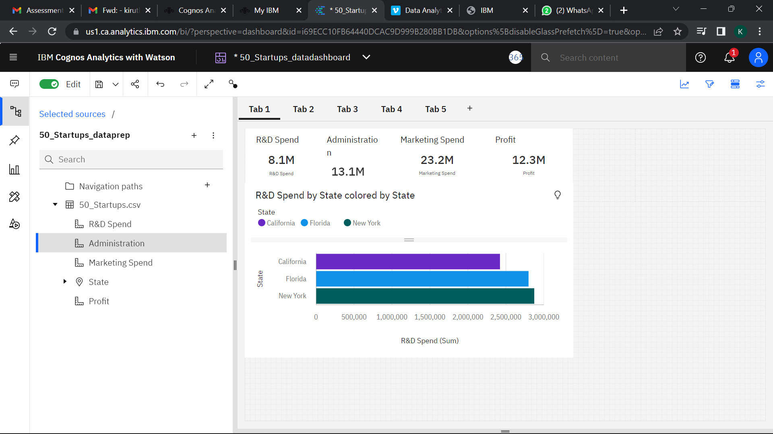

1. **Administration Spending**

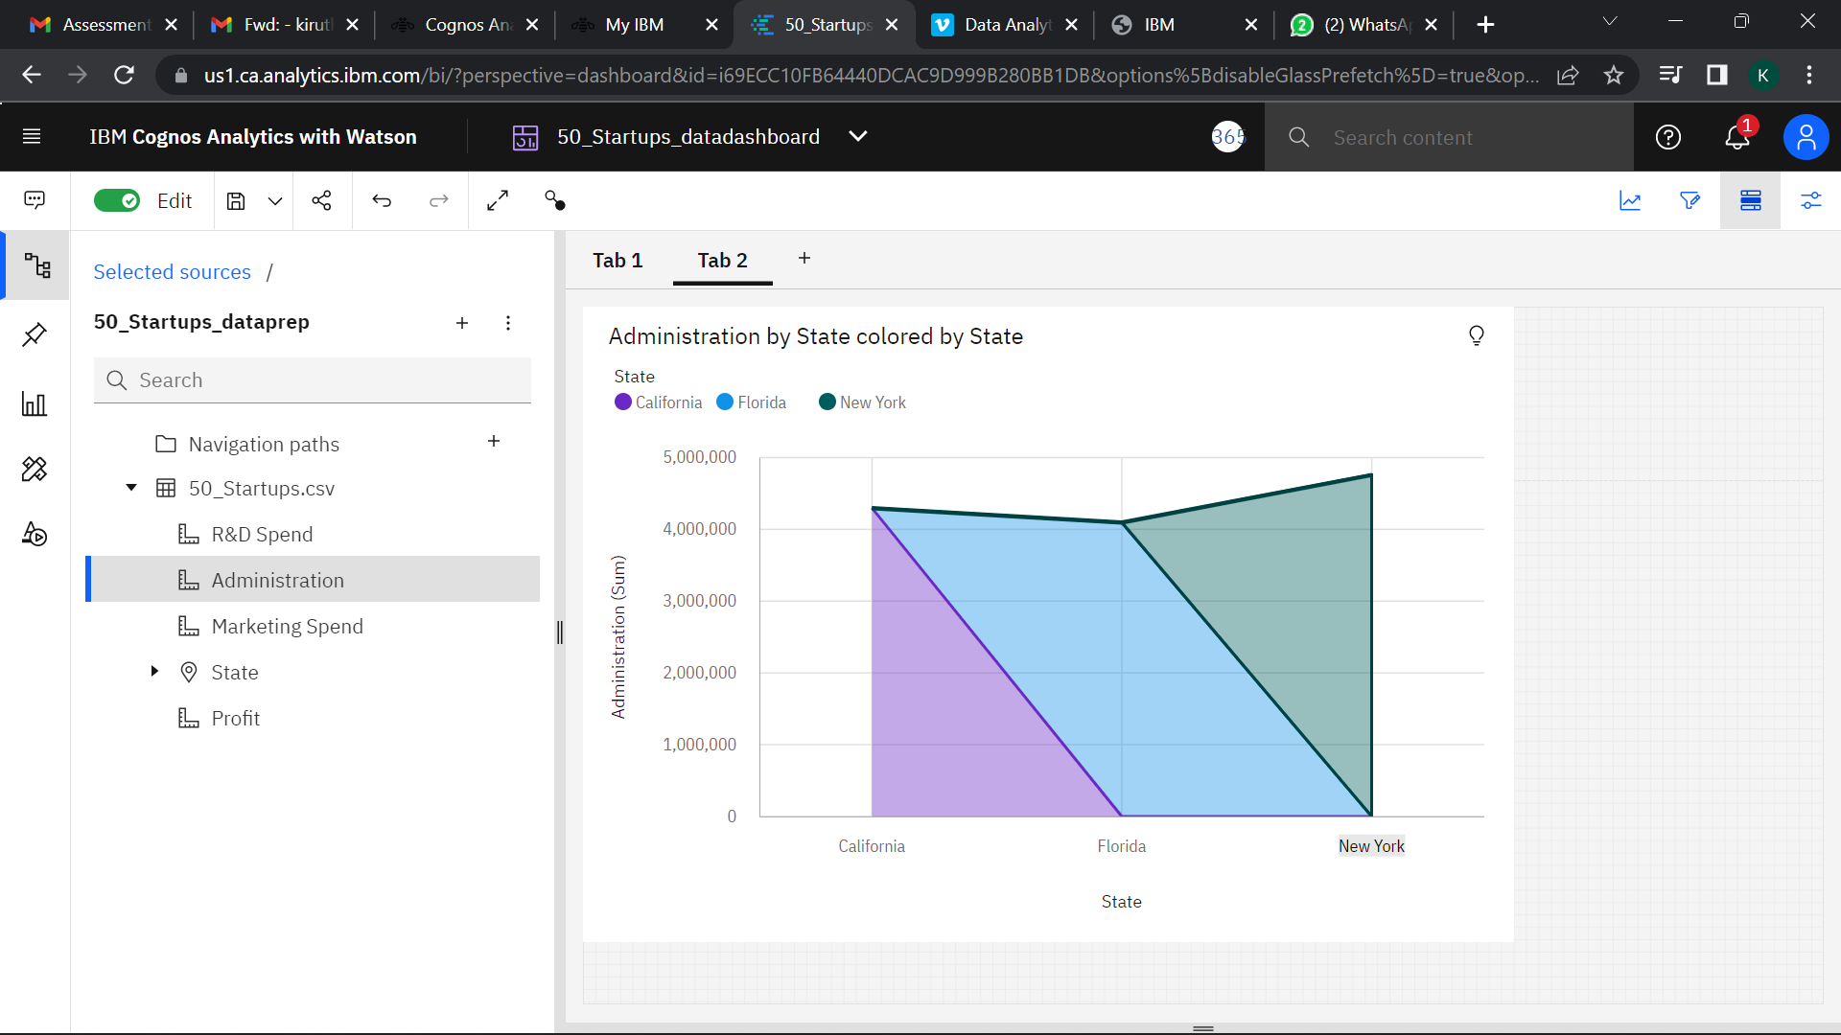

1. **Marketing Spending**

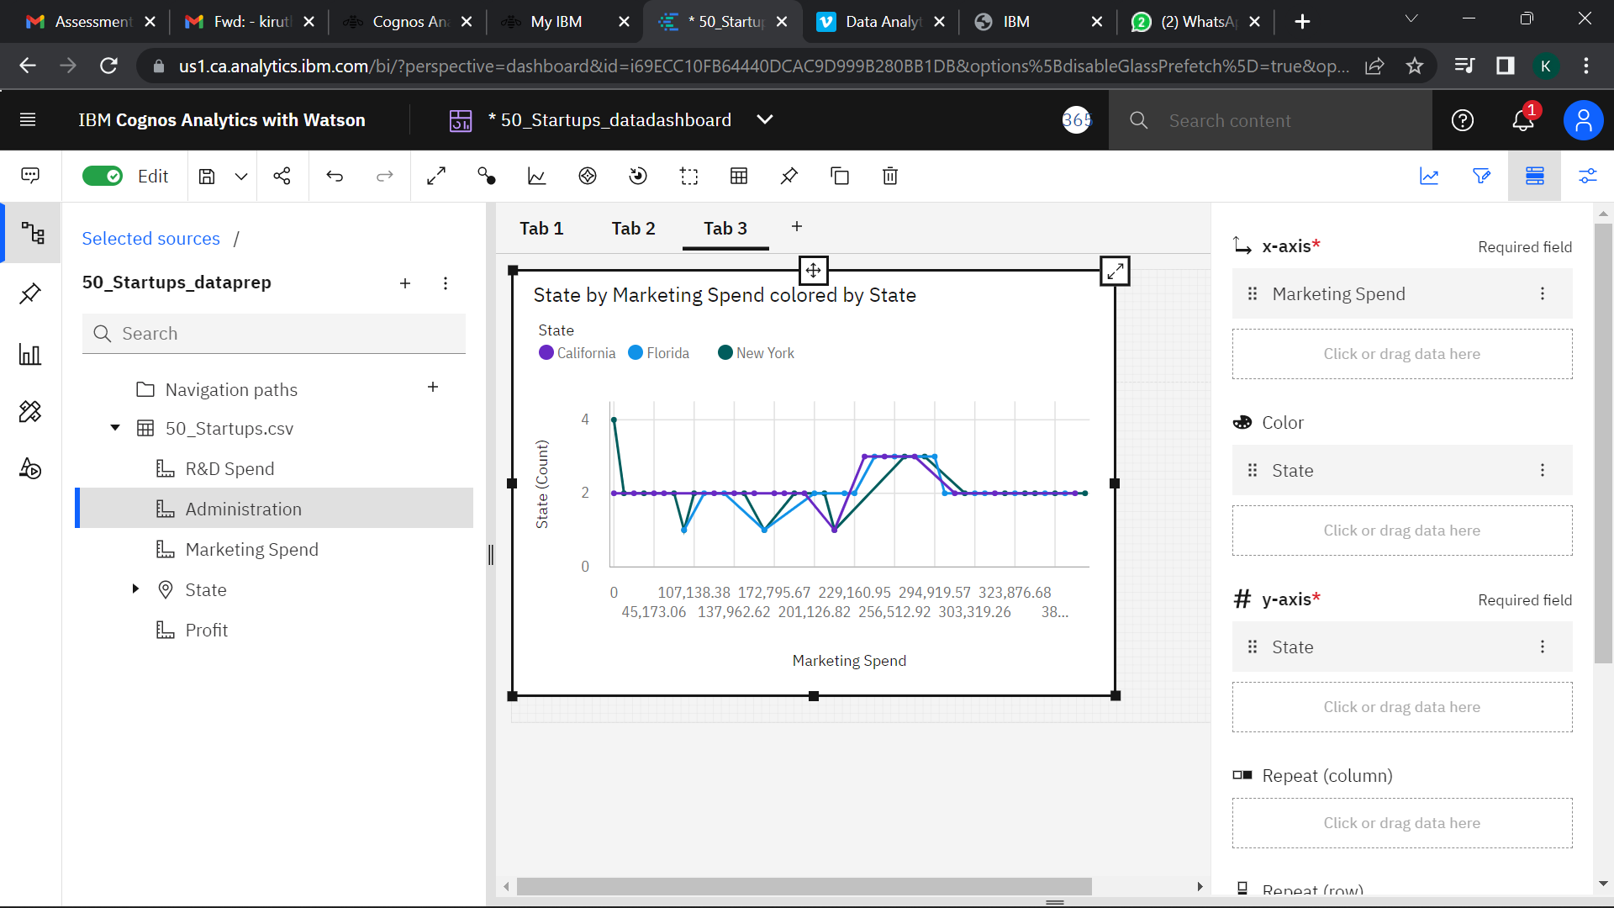

1. **State**

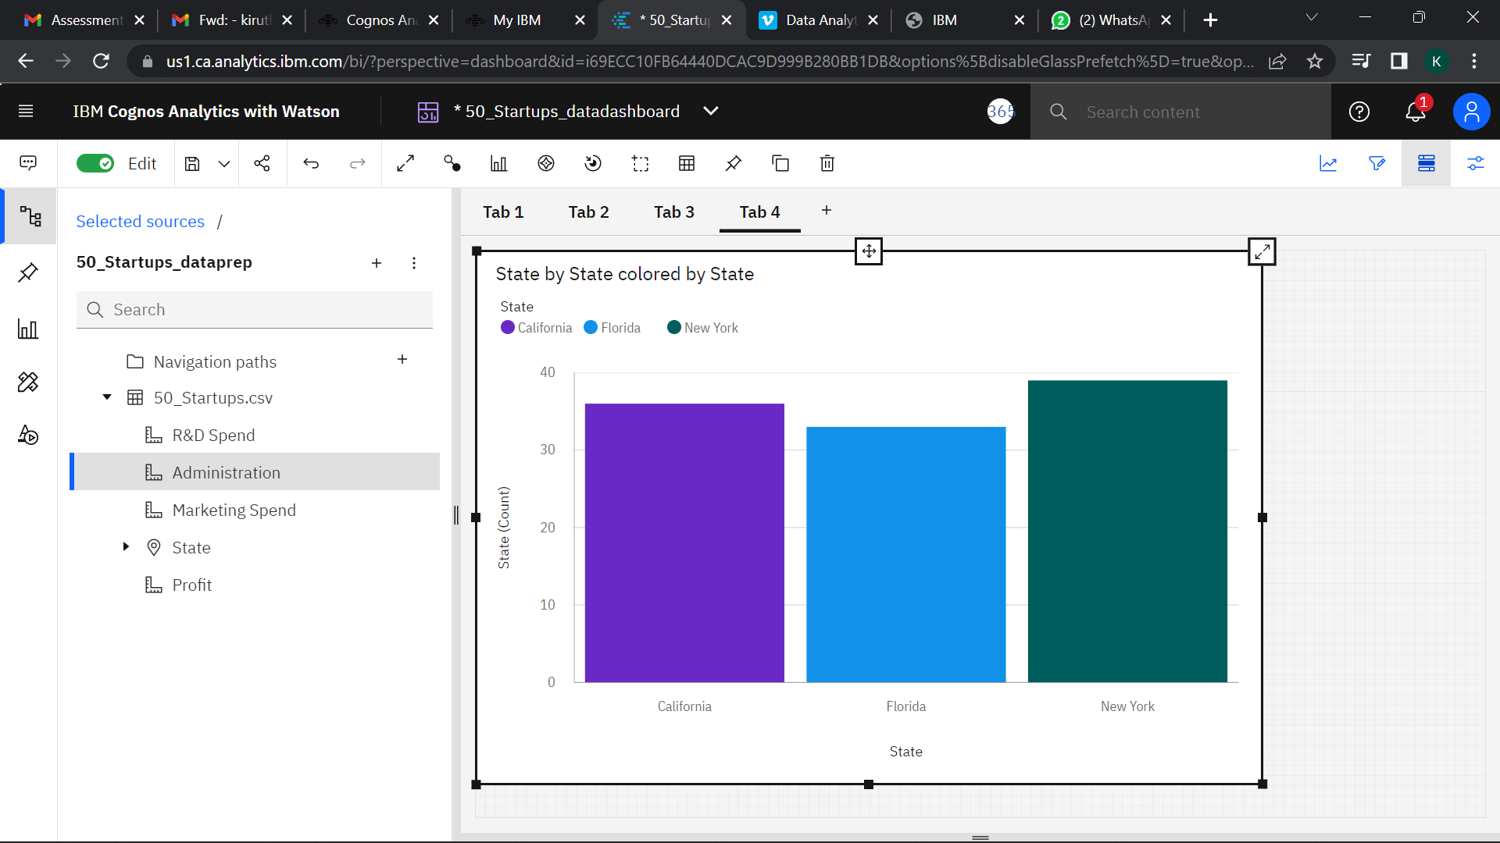

**5.Profit**

